Nunawading Kangas Coaches Booklet

Session 1 Summer 2017-18

Contents
Drills
- Ball Handling
- Shooting
- Passing and pivoting
- Defensive slides
- Shell Drill (defensive rotations)
- Rebounding
- 1 on 1
- Transition defence (stopping the fast break)
Coaching and links
- Training time
- Feedback
- Links

Ball Handling
Zig Zag dribble series

The players start on the baseline as seen, they are then too zigzag their way through the cones so they are forced to keep their dribble tight until they reach the half way line.
They will then dribble to the other side of the halfway line with their outside hand “the hand that is furthest away from the basket”. They will then the dribble to the cones as if they were defenders dribbling from cone to cone and then finish a layup with the correct technique.
As players go through change to between the legs, crossovers, behind the back, retreat dribble etc.
After this has been done a few times the cones can be switched to the other side.
Points of emphasis
- Eyes up
- Down instance when dribbling not standing up
- Fingertips on ball
- Going past the cones tight
- Finishing layup correctly
Right step, left step on right side
Left step, right up on left side
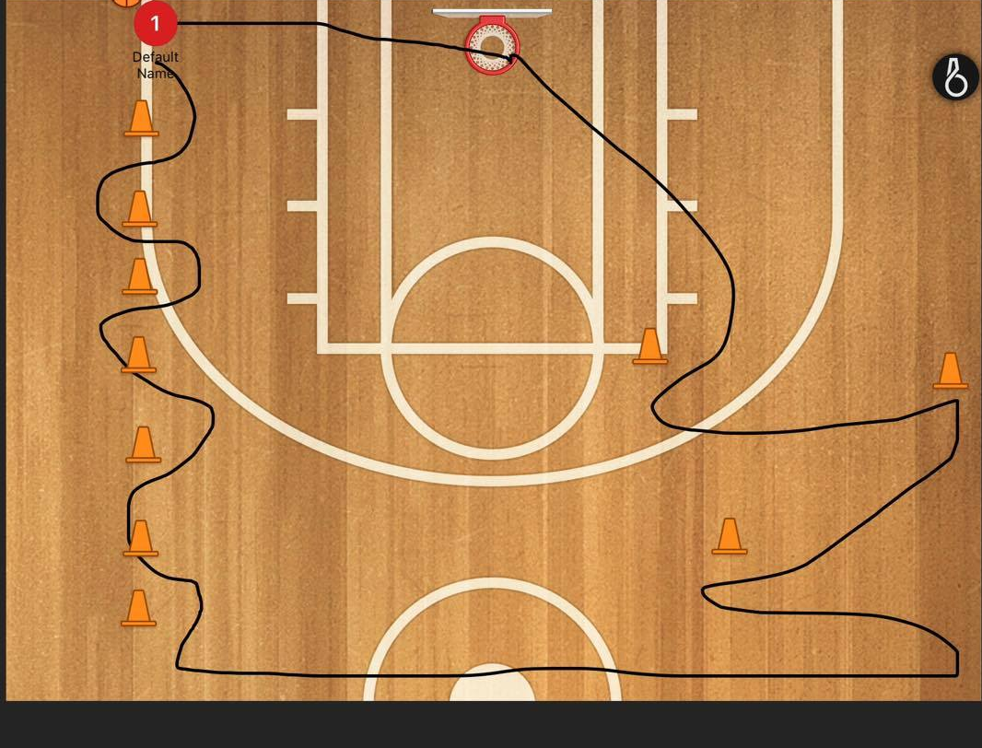

Shooting
Form shooting
This is a good drill for young kids that ruin their shooting form by coming to training and hurling up long 3 point shot and half court shots.
The players will have 3 stages. Charge circle, short corner, 3 point line. (Dependent on age group)
From the charge circle the players are too shoot with 1 hand to get their form right before they move out to shoot a longer distance, as a group they need to make 30 shots from inside before they can move out and use both hands to shoot, at first a practice round is not a bad idea so that they can receive instruction about their form.
They then make 15 from the short corner or free throw line from the middle and 7 3 pointers. The first group to complete this wins.
This drill can be completed by up to 9 players, otherwise there are to many kids waiting in a line.
Points of emphasis
- Elbow in line with the ring
- Hand and fingertips under the ball
- Balanced feet
- Full extension on release. (emu head)
- Step into the ball to receive it in a shooters stance (back straight, but down, hands ready to receive)
- Good passes

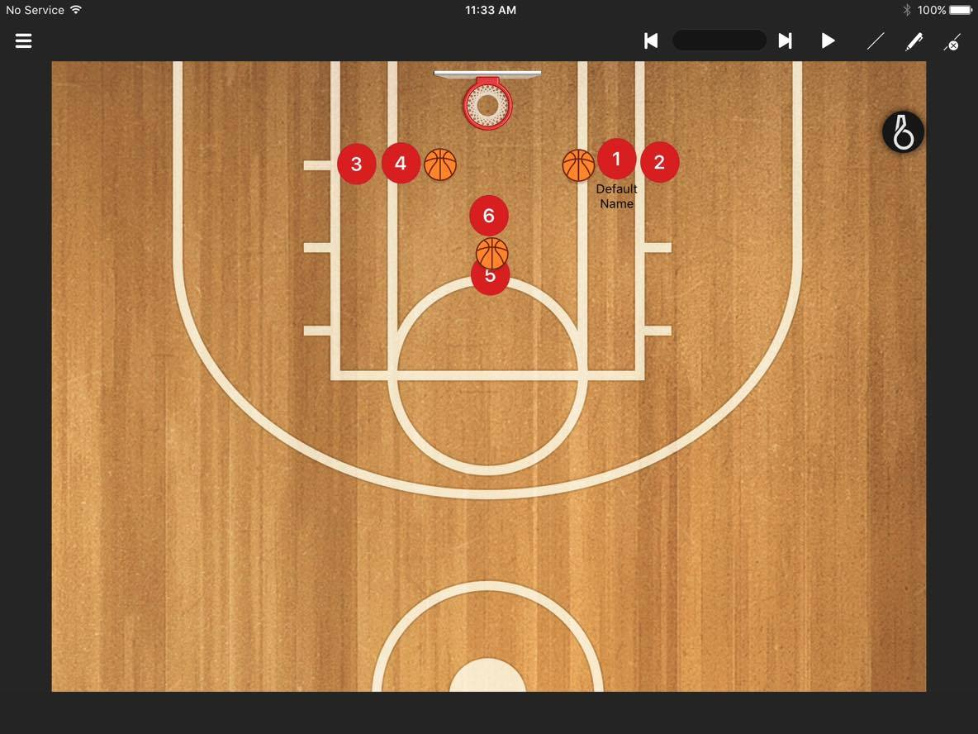
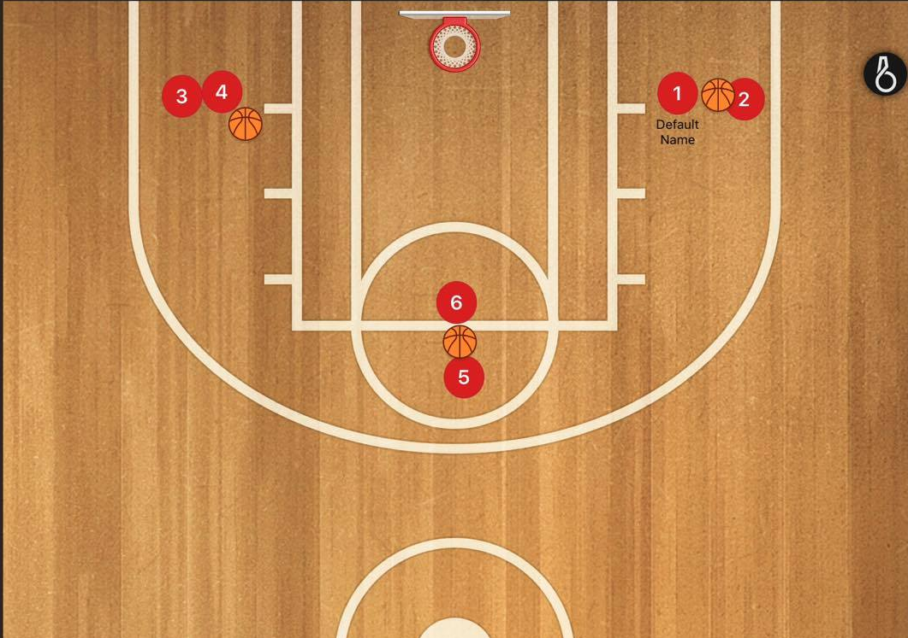

Passing and pivoting
Foul line extended shooting
Pivoting in particular can be an extremely hard thing to get kids to learn, as it is the most boring to do. It can be very beneficial to put it in a shooting and passing drill so they will have a further interest in learning it.
The players will be in 2 lines at the foul line extended on both sides, there will be a ball in 1 line. The players in the shooting line are to cut down to the block and then run to the free throw line to receive the ball on their inside foot (foot closest to the basket) and shoot.
After the pass the player is to join the opposite line and the shooter will rebound his own shot, pass to the passing line and join that line.
Points of emphasis
- Using the inside foot
- Catching in stance
- Hard passes to the chest
- Calling hard for the ball
Order of pictures is left to right

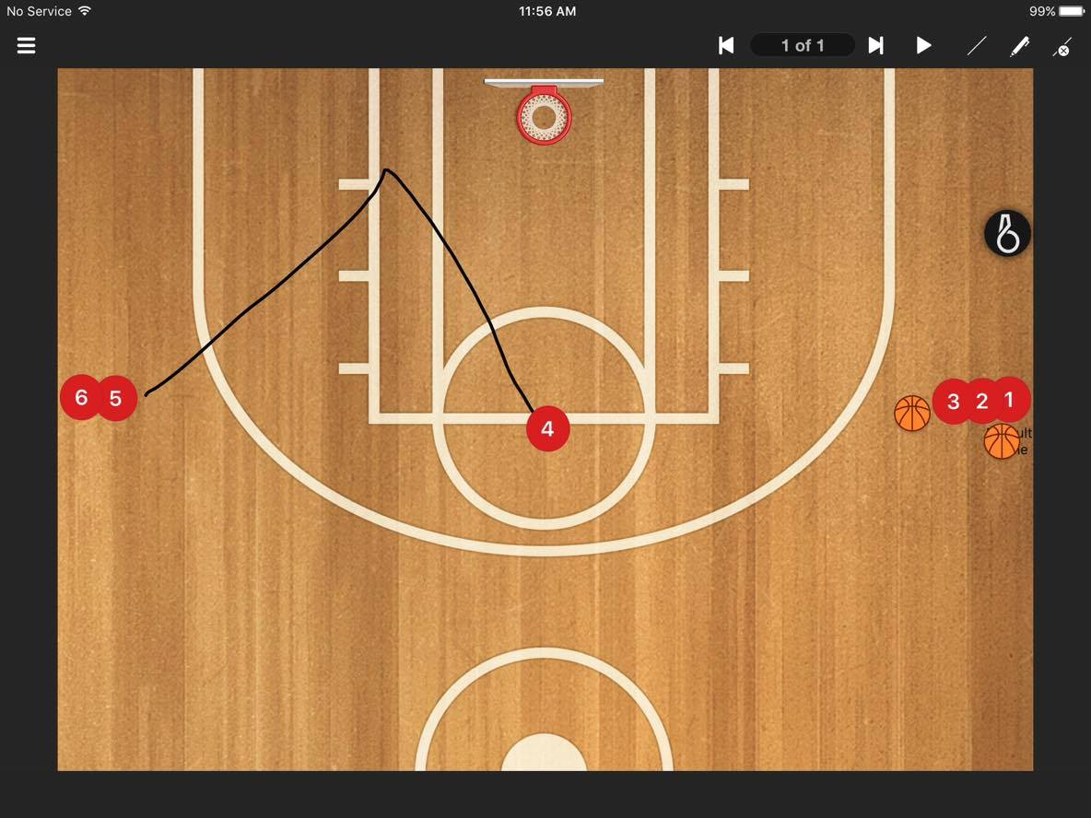
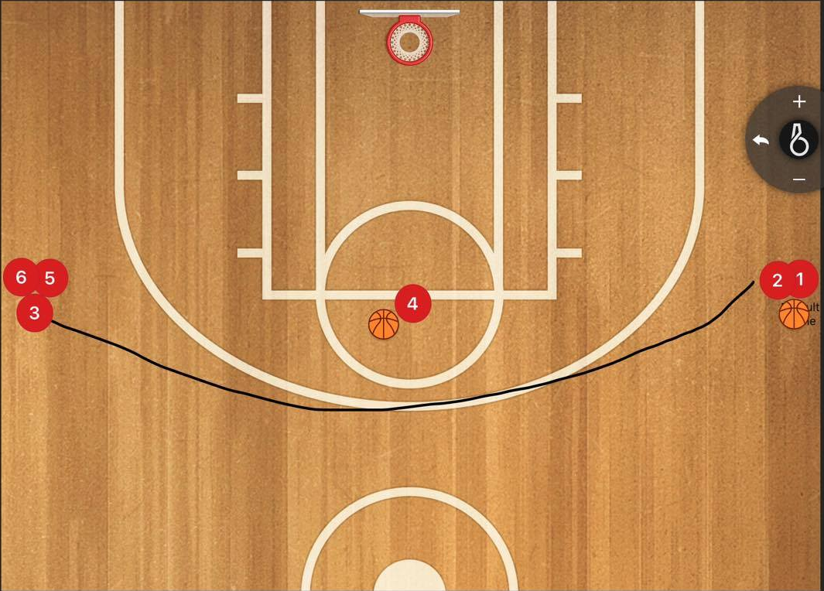
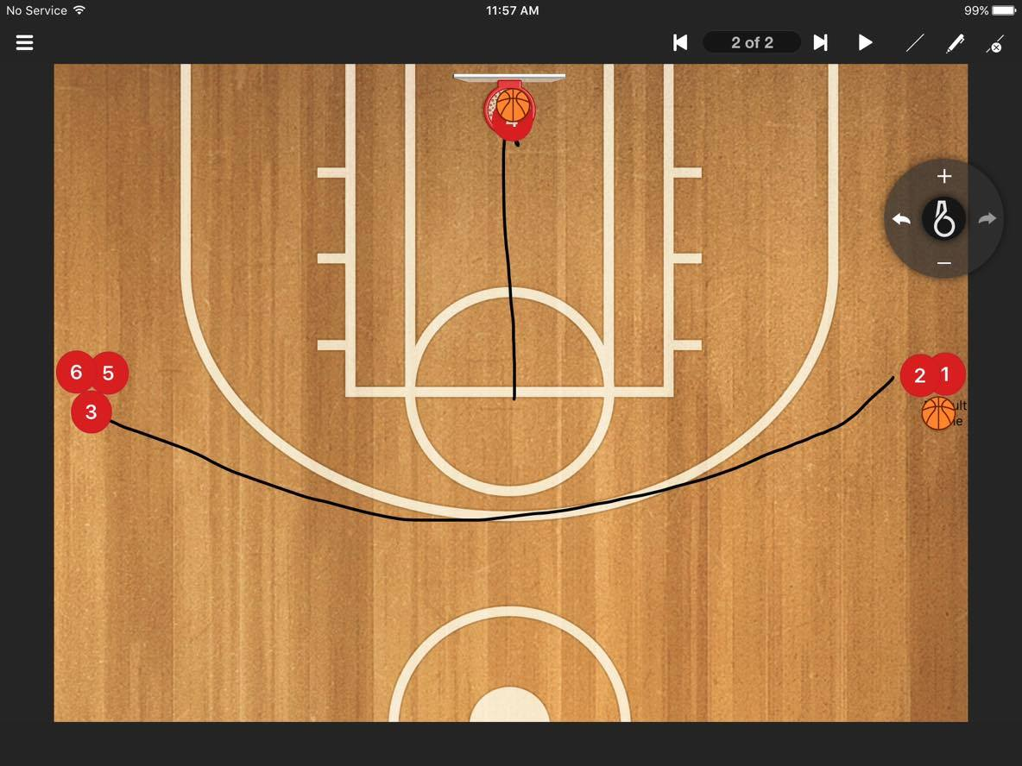
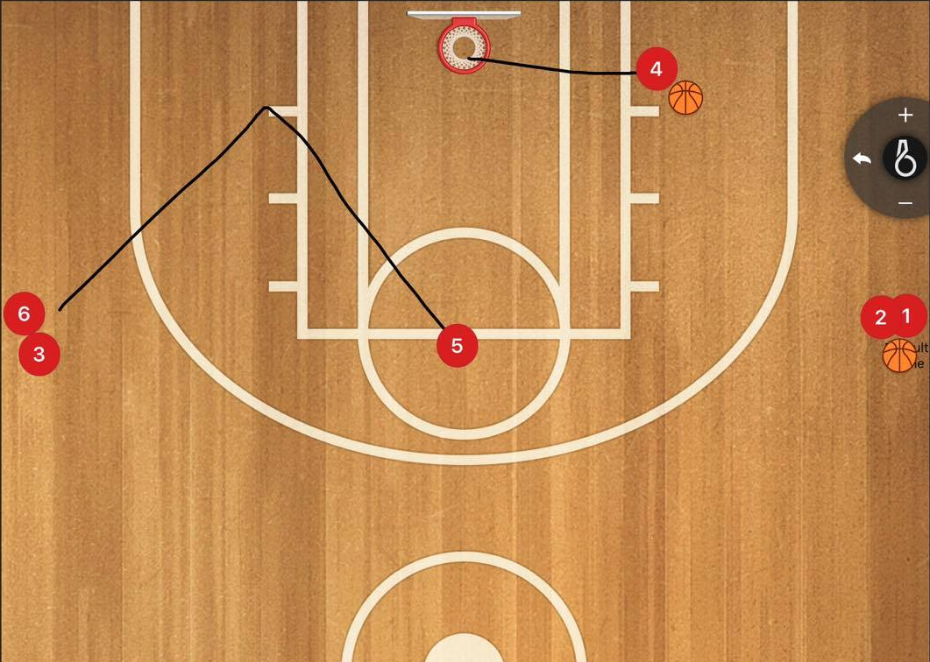

Passing and pivoting continued
Key line passing
The players will pair up with 1 ball between 2 on 1 side of the key line each. They will be throwing bounce passes, chest passes, overhead passes and step around push passes to each other back and forth.
Note this drill is a base fundamental drill and players will easily become disinterested and bored if it is done for longer than 10 minutes maximum. Young kids standing still for too long are never an ideal situation.
As a bonus, coaches can throw in forward pivoting and reverse pivoting after the catch of a pas as well.
Points of emphasis
Chest passes
- In stance, flick wrists so that thumbs are facing down
- Step into pass like a stride
- Hands up to receive.

Bounce passes
- In stance, flick wrists so thumbs are facing down.
- Flick wrists so they are facing down
- Step into pass like a stride
- Make all Bounce 3/4 of distance hard into floor so it comes up into the chest.
- Hands up to receive.

Overhead passes
- In stance
- Do not bring ball behind head, sit ball over forehead
- Stride into the pass low and use body for power.
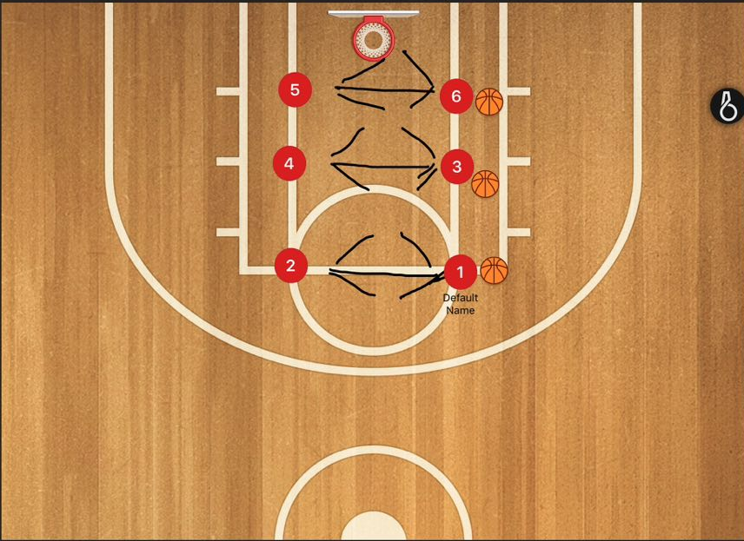
- Swing arms forward
- Hands up to receive
Step around push passes
- Stay low and step to side
- Place ball on hip
- Push ball with outside hand
- Get shoulder behind ball

Passing and pivoting continued
A more advanced passing drill where kids have to move to get the ball is four corners passing.
This drill can be harder to explain so I have attached a link with a video for easier understanding.
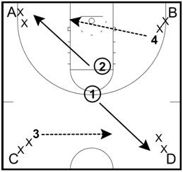
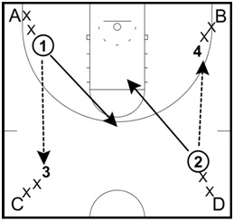
https://www.breakthroughbasketball.com/drills/4-corners-passing.html

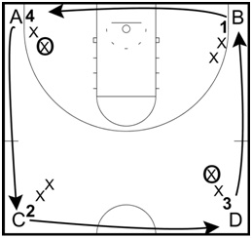
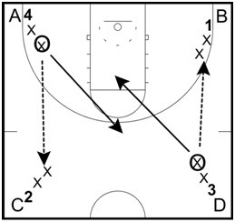

Defensive slides
ZigZag sliding series.
This drill involves the players being in a situation where they have been guarding their player, then have been beaten and need to sprint to get back in front.
The players will slide to their 1st cone and then quickly sprint to the next cone, they will then slide to the next cone, then sprint to the one that follows in that pattern until they have finished.
Note: Term is technically defensive “slides”, however as coaches we want players to just stay in front, what will slow them down is dragging their back foot to a position, instead of a slide, it is more of a push off the player should be making when moving from one cone to another when playing defence.
IMPORTANT: The player should be facing forward the entire time and facing the wall when playing defence.
P.O.E
1. Not dragging feet, pushing off back foot to move
2. Stay low, the lower the quicker the player will be laterally.
3. Wide hands, be big
Slide
Sprint

4. Be on the balls of your feet
5. Back straight, but down
6. Turn and sprint hard, no jog.
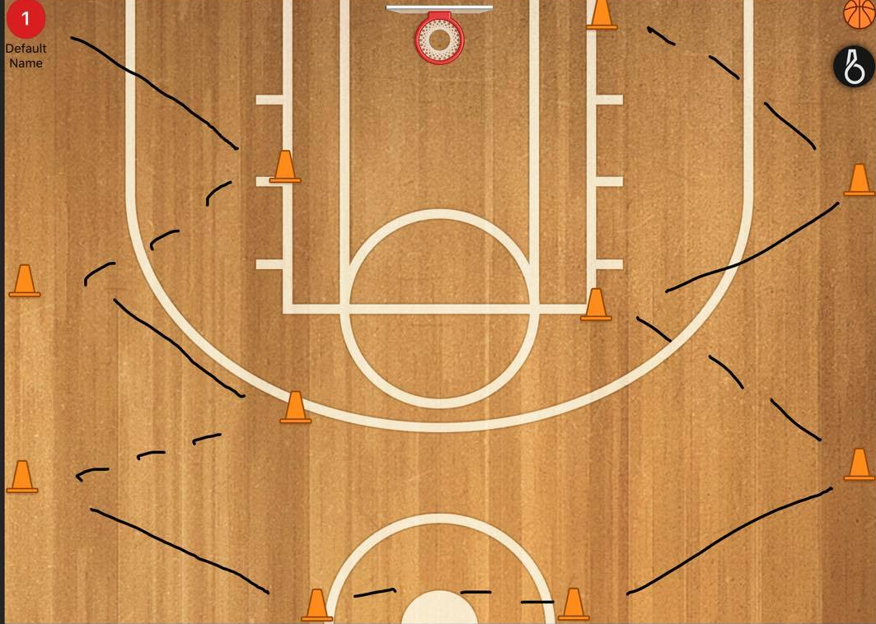

Shell drill (defensive rotations)
This drill is about defensive rotations, this is how you would defend a team in a half court man to man set.
However depending on age group, ability and team makeup, you may defend using the “Pac-line” defence or “denial” defence.
Pac-line defence involves guarding the driving lanes on the court instead of stepping up and putting high pressure players off the ball, overall its aim is to stop dribble penetration.
Denial defence involves putting pressure on the passing lanes and not letting he team moving the ball get a catch.
Pac-line
Advantages
- Better at stopping dribble penetration
- Can help hide slow defenders
- Does not over pressure a team on the perimeter that cannot shoot.

Disadvantages
- Team can move ball around court as they like
- Slightly more open to a team shooting over defence from the perimeter.
- Does not put much pressure on offense, stops will be caused by steals on drives and forcing missed shots.
Denial
Advantages
- Puts high pressure on offensive team, makes it hard for them to run through set plays.
- Able to defend shooters easier.
- Easier to target and individually attack weaker players on offensive team
Disadvantages
- Leaves players vulnerable to be beaten 1 on 1.
- Players can be over eager to steal the ball and can be back cut on.
- Less ability to guard driving lane and help

A simple way to practice this is to set your players up in a basic “5 out” and make them pass the ball around against defenders and the defenders have to rotate accordingly depending on what defence they are playing whether it be denial or Pac-line.
Weather it is Pac-line or denial, your player’s goals should be to always fill 3 important spots.
- BALL (0 PASSES AWAY)
- HELP (1 PASS AWAY)
- SPLITLINE (2 OR MORE PASES AWAY)
Split line is the imaginary line that runs through the middle of the court rim to rim

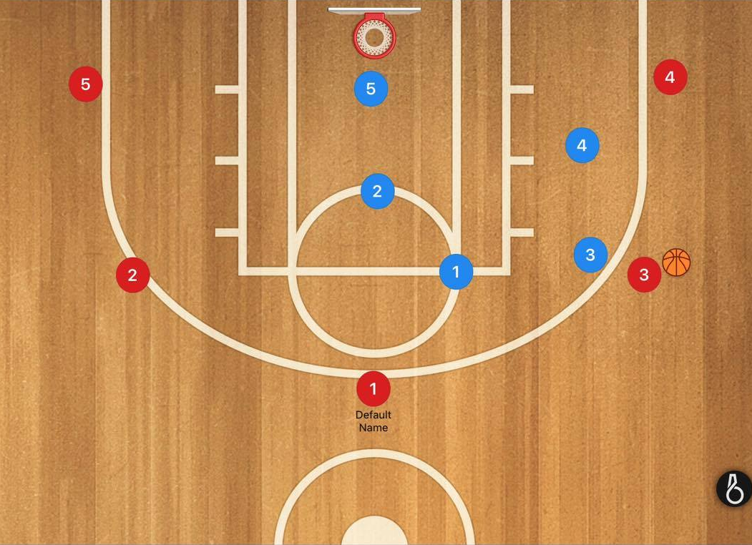
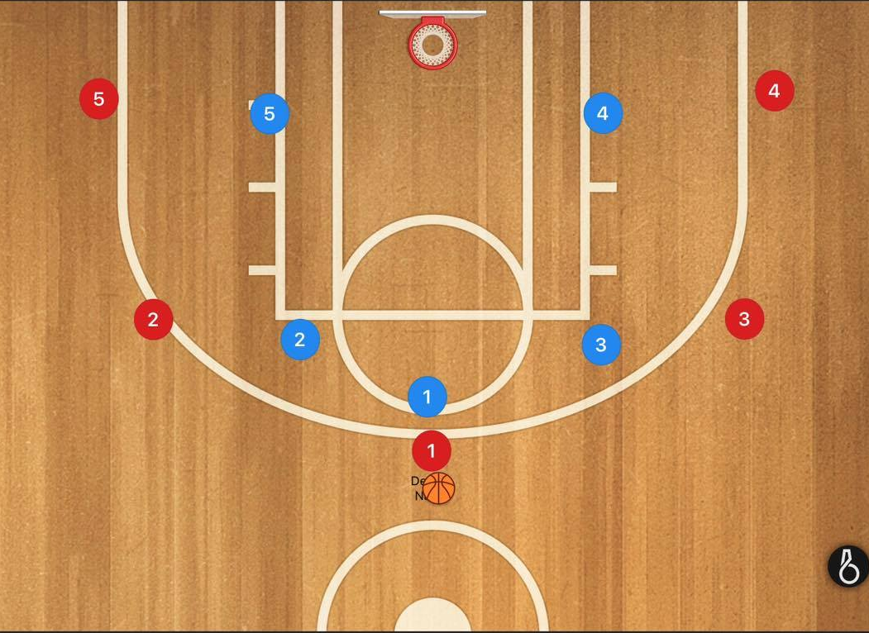
Rotations for Pac-line defence (protect lanes)
Pac- Line positions
4 man and 1 man are 1 pass away and are therefore in “help” position
2 man and 5 man are 2 or more passes away and therefore are in “split line” position”
help
split line
ball
help
split line
It is hard to nail on the head on paper where exactly the players should be in this drill because it depends on YOUR TEAMS ABILITY AND AGE GROUP.

For example in the picture to the right it would be appropriate for the blue “2” man to be standing where he is from around under 8-14s. After that players would be strong enough to skip the ball over to his player before he could get there to defend it.

Rebounding
Close box
Boxing out is the most important thing in rebounding. It involves a player moving in front of another play pushing back into that player with their hips to get into a better position for a rebound.
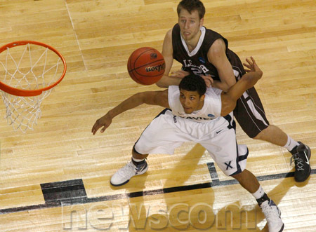
In this drill the players will be in 2 lines where the key line meets the baseline, with 1 shooter on the elbow waiting to receive the ball.
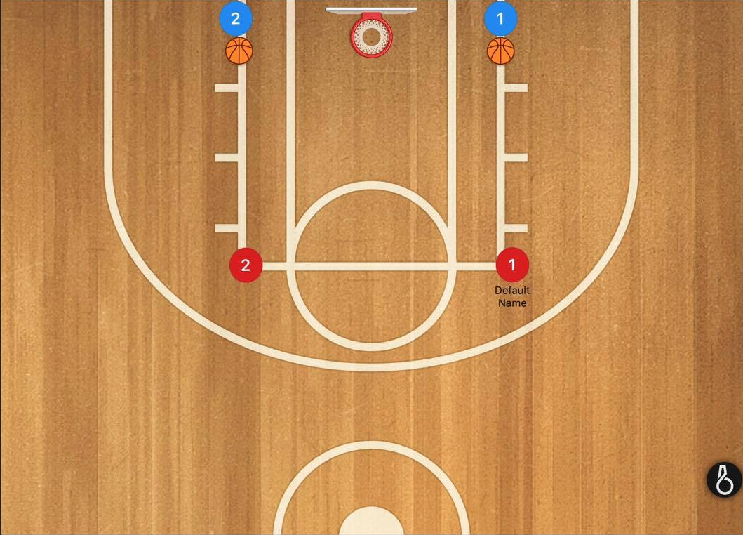
The ball will be passed from the baseline to the shooter who takes the shot, the player who passed him the ball will run out to him in an attempt to contest the shot. After that he will box out the shooter and will try and make the ball bounce twice before he grabs it, he is to not let the shooter get his own rebound. 1 group will go at a time.

Rebounding continued
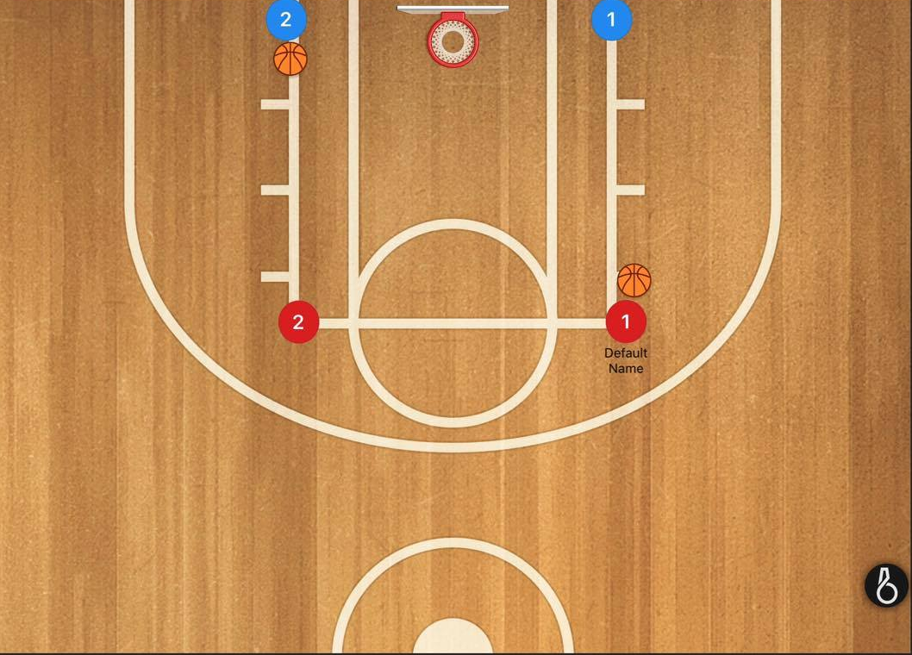
2.

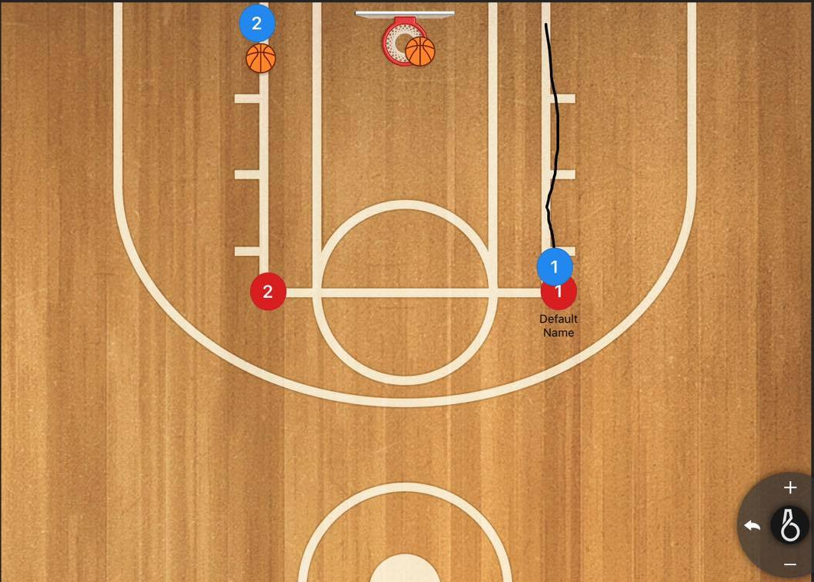
3.

1 on 1
Wing and top entry 1 on 1
In this drill, to begin there will be 1 line on the wing and 1 line at the top of the key.
The 1st person in the line on the wing will be a defender and the 2nd person will be the offensive player, a pass will then be made from the line at the top to the offensive player on the wing. The 2 players on the wing will the play 1 on 1 from there and the offensive player will have 5 seconds to score.
The passer will go to the offensive line, the defender will go to the passing line and the offensive player will become the defensive player.
Points of emphasis
- The use of a jab step
- The use of a rip and go
- “Sealing” the defender with the inside foot on the way to the basket
- Offensive player to say low in stance
- “Crush toes or break nose” don’t rip the ball through a players belly button.
- Players are to cut to the basket and then out to receive ball if they are covered.

Here are some videos on teaching 1 on 1 to reach the above points of emphasis
https://www.youtube.com/watch?v=3pTdYzNSPiU
https://www.youtube.com/watch?v=JZEVLrA2UMg
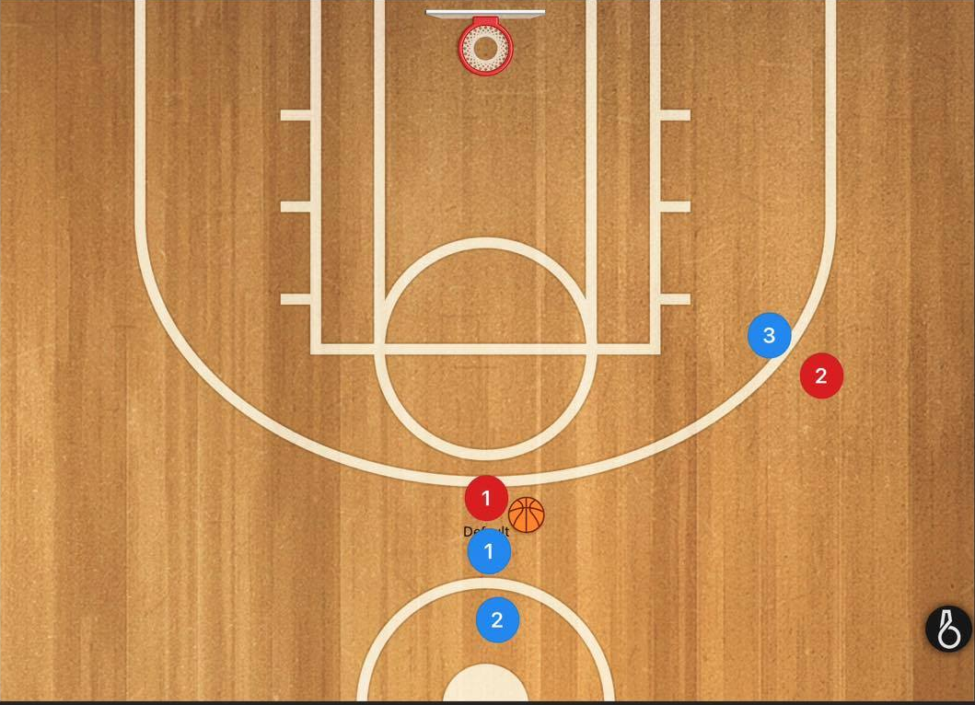

1 on 1 line

Passing line
2.
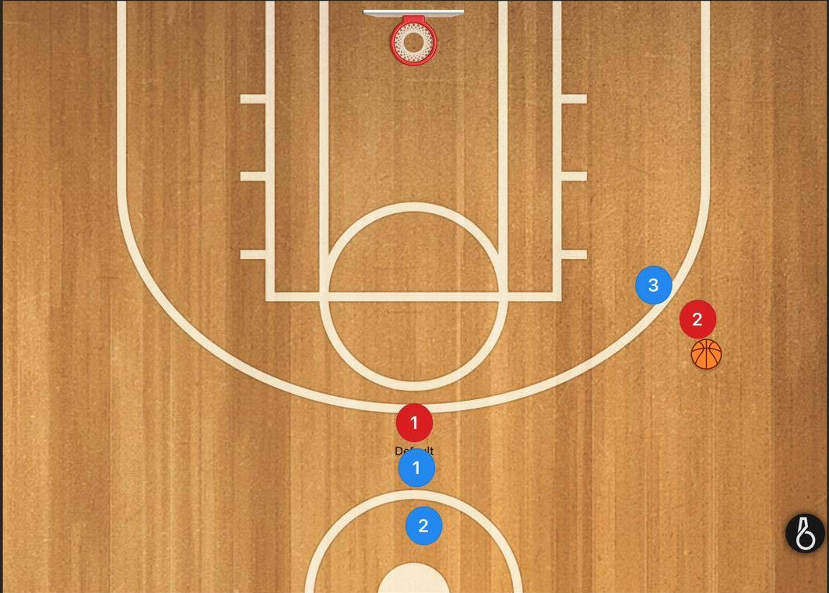

3.
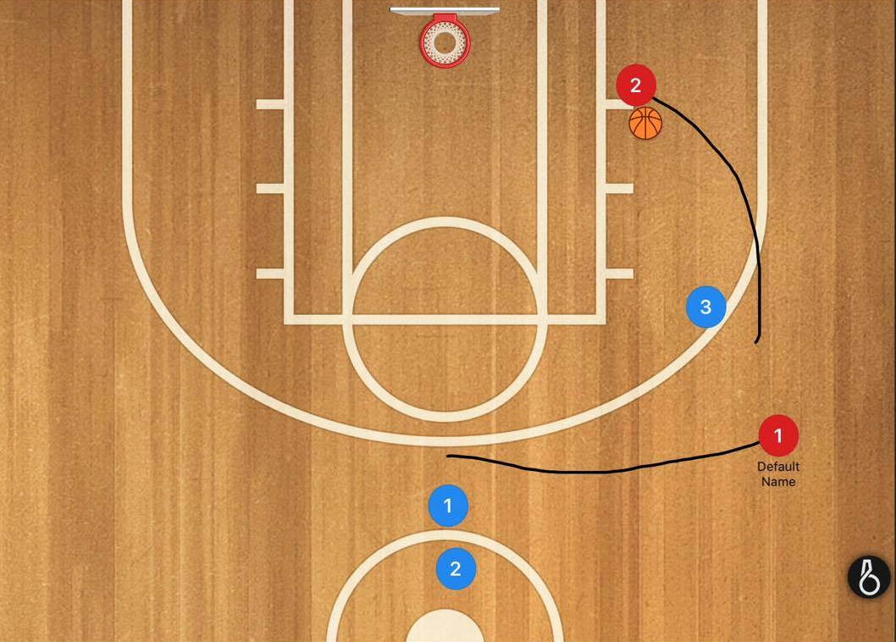
Red player 2 has beaten blue defender 3 to the basket
Red player 1 will now change to the 1 on 1 line
Red player 2 will go to the passing line
Blue player 3 will now go to offense in the 1 on 1 line.

Transition defence
Name break
Set-up:
5 offensive players on the baseline with 5 defensive players across the foul-line extended, as shown.
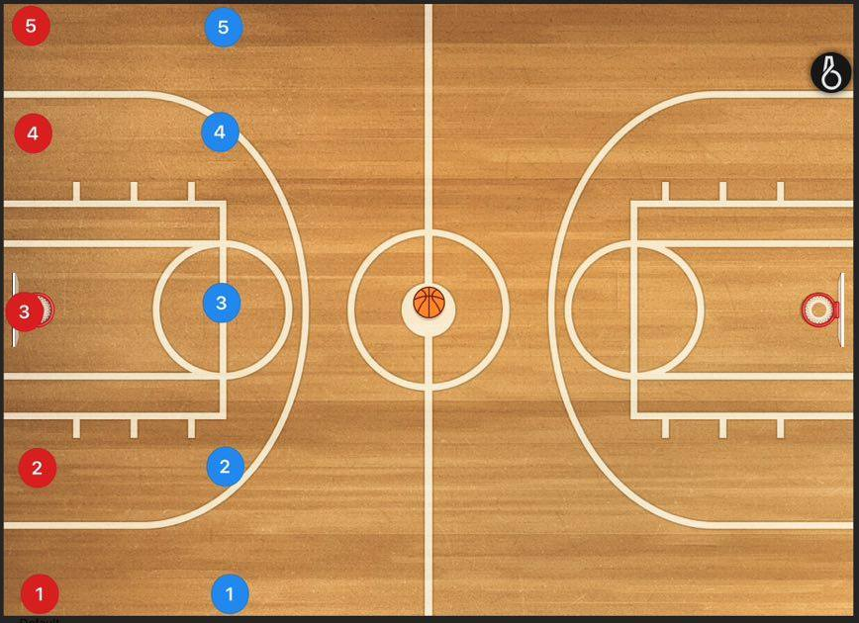
Defence
Offense

Step 1:
The coach throws the ball to any offensive player on the baseline
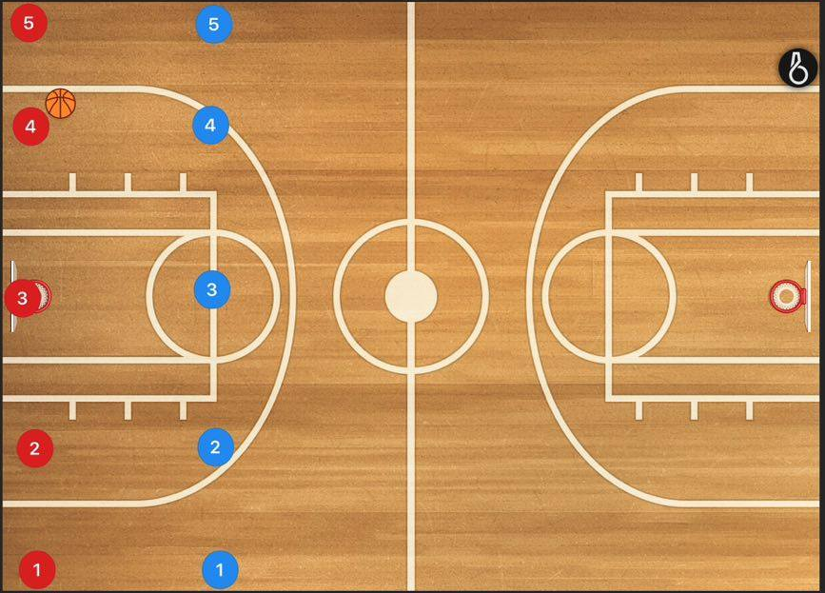

Step 2:
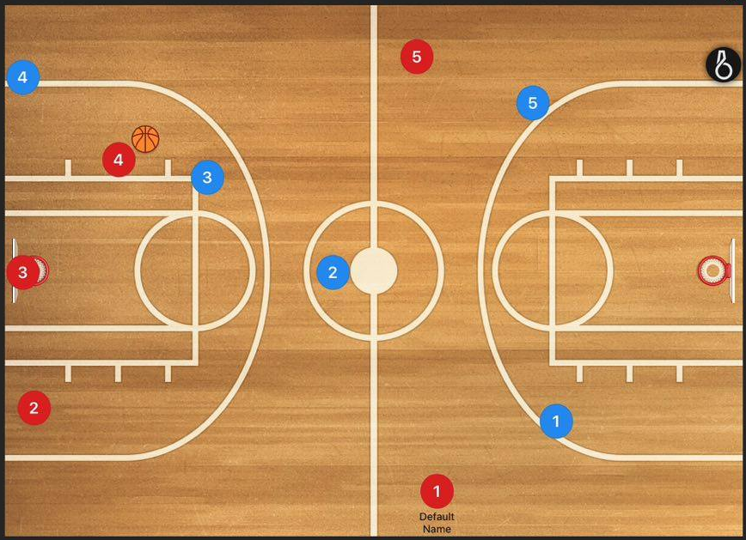
The defender facing the player with the ball is to run and touch the baseline. In this case, the 4 man has run and touch the base line.

Lane defender
Ball stopper

Plugger

Lane defender

It is then up to the defence to react, and up to the offence to score in the opposite basket.
There are 3 keys to transition defence which the defensive team must look to do.
- Stop the ball. This is the first priority (3 man in above diagram)
- “Plug” the middle of the floor (2 man in above diagram). The plugger should be further down the court then the ball handler and towards the middle of the floor. This will force the ball handler to a sideline, and act as ‘safety’ if the defender on the ball is beaten.
- Cover the lane runners down the court to protect the basket (5 and 1 man in above diagram). It is important these players do not chase the ball as this will leave their players open for an easy lay-up.
A win for the defence is to stop the fast break and hold the offense for enough time that the 4 man can get back on defence.

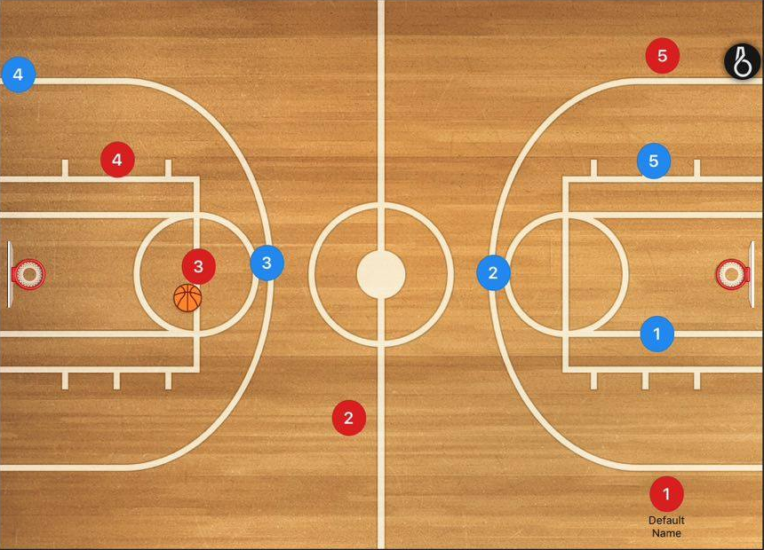
In the below this situation, the ball has been passed across to the 3man. As the ball is defences first priority, the defensive 3 man has moved over to stop the ball. The plugger has also moved back a few steps.

Ball stopper
Plugger

Step 3:
Step 3:
The 4 man has now caught up, and the defence is now able to float back into a half court defence.
The teams switch over and the drill begins again.
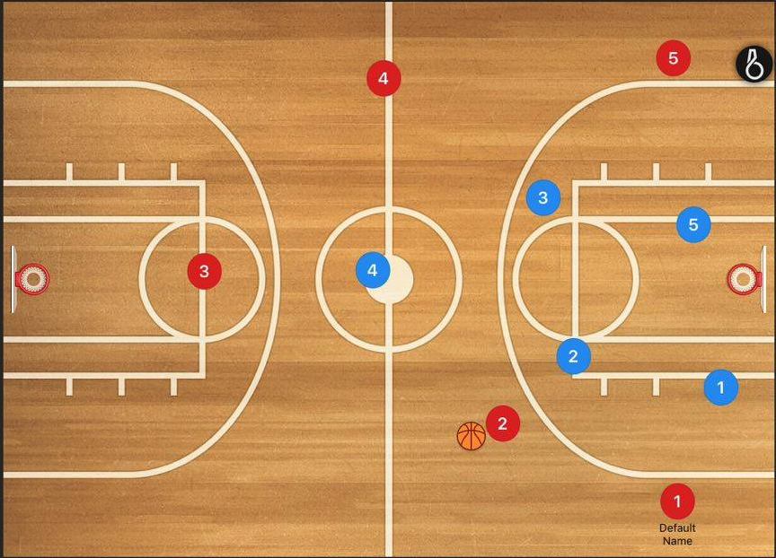

Lane defender

Coaching

Training time
Some things to remember when running training
- Limit the number of kids waiting in lines, or they will cause trouble
- If you have drills/sets you need to work on that require them to be still or involve less moving around, give them a high intensity drill before it or for young kids reward them after with a fun game.
- Have eyes on all of your kids, we have been in trouble before with kids jumping on mats/school props etc
- If you are closing remember to turn off ALL of the lights
- If you are lucky enough to have 2 rings or even a full court, use it.
- Encourage the coach on the other side of the court to become involved in some full court drills together if they are in a close age bracket.
- Make trainings competitive

Feedback
When we are coaching, commonly we all jump to a player making a mistake with saying exactly what they did wrong, or we are to negative. Here is an example of one we have all probably heard countless times.
“What are you doing throwing the ball out of bounds!”
This has given the player no feedback on what to do next time when they are in the same situation and they are now more likely to make the same mistake and be afraid of making mistakes.
The problem is not the pass itself; it is where we threw it.
For example I was at a Friday night rep game that was playing before my team, I overheard what the coach had to say in his time out when his team was down by 1 point with 8 minutes to play, it is again a very common thing to hear.
He listed all the problems they were having but not the solutions, while putting unnecessary pressure by yelling at the boys in a game where they are already feeling pressure.
Quote:
“Guys, we have got to rebound the ball, seriously can we knock some shots down? We have got to stop turning the ball over and stop throwing bad passes, number 30 has scored the last 6 points c’mon fellas!”

Obviously if you put your hand on a stove and feel pain, you know you shouldn’t do that again.
Same meaning here, the players already understand that turning the ball over is bad and it is going to hurt them the more it happens, and obviously they have to score to win the game, and they have just seen number 30 score the last 6 points.
So as a player when you walk back out onto the court, you still have not yet figured out...
How we can stop giving up rebounds?
How can we stop turning the ball over?
How do we shut down number 30?

We are all guilty of this at some stage when we become frustrated.
A more appropriate answer may be..
“Fellas, it’s all good. We just switched off for 2 minutes; let’s make sure we are communicating on what number we have when we’re manning up so there’s no confusion on who has to box out who. Against this press make sure that we get to our spots as soon as it’s our ball on the baseline and we get a wide catch on one side of the court and then switch it onto the other side and move it up the line with a pass. Just make sure we’re not going under the on ball screens on the perimeter that are leaving number 30 open for shots. If we’re not doing those things and were only down by a point, if you do half these things you will win the game, let’s go”.

Links

Ball handling, Shooting, Passing, Dribbling, Pivoting,
http://www.basketballforcoaches.com/basketball-drills-and-games-for-kids/#ShootingDrills
Rebounding
https://www.breakthroughbasketball.com/fundamentals/rebounding-fundamentals-and-tips.html
1 on 1
http://basketballimmersion.com/value-teaching-one-one-drills/
NO ZONE
http://www.basketballforcoaches.com/zone-defense-youth-basketball/
Transition defence
http://www.richstoner.com/the-keys-to-effective-transition-defense
Defensive slides
https://www.breakthroughbasketball.com/defense/step-slide.html

Thank you for your continued work in coaching at the club, and good luck for the coming season.
Regards,
Ryan Moran
Coach Coordinator
nuna.kangas.coachcoordinator@gmail.com
0419545853

